DataBase_Assignments Assignments 1create table orders ( onum int (4),amt float (7,2),odate date , cnum int (4),snum int (4));insert into orders values (3001,18.69,'1990-10-03',2008,1007);insert into orders values (3003,767.19,'1990-10-03',2001,1001);insert into orders values (3002,1900.10,'1990-10-03',2007,1004);insert into orders values (3005,5160.45,'1990-10-03',2003,1002);insert into orders values (3006,1098.16,'1990-10-03',2008,1007);insert into orders values (3009,1713.23,'1990-10-04',2002,1003);insert into orders values (3007,75.75,'1990-10-04',2004,1002);insert into orders values (3008,4723.00,'1990-10-05',2006,1001);insert into orders values (3010,1309.95,'1990-10-06',2004,1002);insert into orders values (3011,9891.88,'1990-10-06',2006,1001);create table customers ( cnum int (4),cname varchar (10),city varchar (10),rating int (4),snum int (4));insert into customers values (2001,'hoffman','london',100,1001);insert into customers values (2002,'giovanni','rome',200,1003);insert into customers values (2003,'liu','san jose',200,1002);insert into customers values (2004,'grass','berlin',300,1002);insert into customers values (2006,'clemens','london',100,1001);insert into customers values (2008,'cisneros','san jose',300,1007);insert into customers values (2007,'pereira','rome',100,1004);create table salespeople ( snum int (4), sname varchar (10),city varchar (10),comm float (3,2));insert into salespeople values (1001,'peel','london',.12);insert into salespeople values (1002,'serres','san joes',.13);insert into salespeople values (1004,'motika','london',.11);insert into salespeople values (1007,'rifkin','barcelona',.15);insert into salespeople values (1003,'axelrod','new york',.10);

select *from orders;select * from salespeople;
select *from customers;
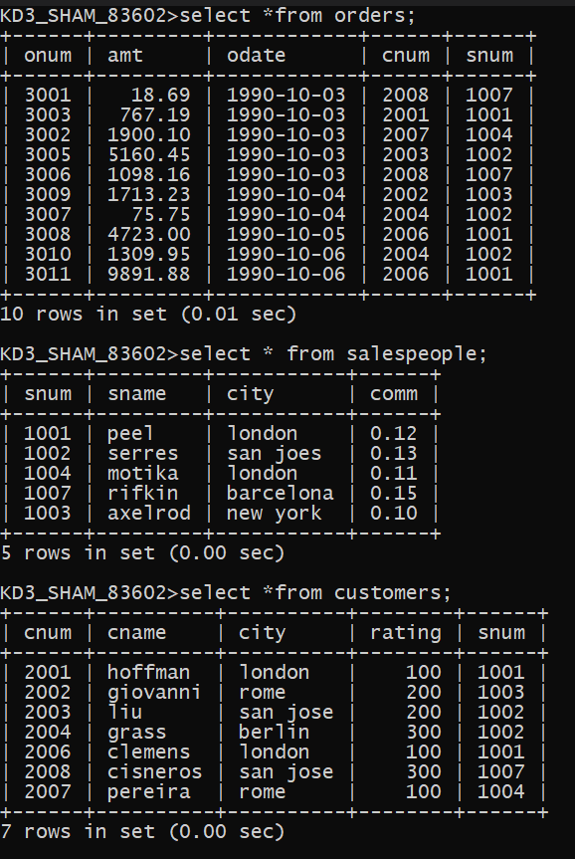 Assignments 2Q.1 Which field of the customer table is primary key ?Q.2 What is the 4th column of customer table?Ans. RatingQ.3 What is another word for row and column?Ans. Row is also called as tuple, entity, opportinity Column is also called as attributes, methods , keysQ.4 Why isnt it possible to see 1st 5 rows of a table?Ans. The rows are stored at diffrent places in a server HDD in a file format. And theyare called sequentially as per there address. No specific location is given to the rows.Thats why it is not possible to see 1st 5 rows of the table.

Assignments 3Q.1 Does ANSI recognise the data type DATE?Ans : ANSI dosent recognise the date datatype.Q.2 Which subdivison of SQL is used to insert values in tables?Ans : INSERT into is usedIt is a DML command

Assignments 4select onum,amt,odate from orders;select * from customers where snum = 1001;select city,sname,snum,comm from salespeople;select rating,cname from customers where city='san jose';

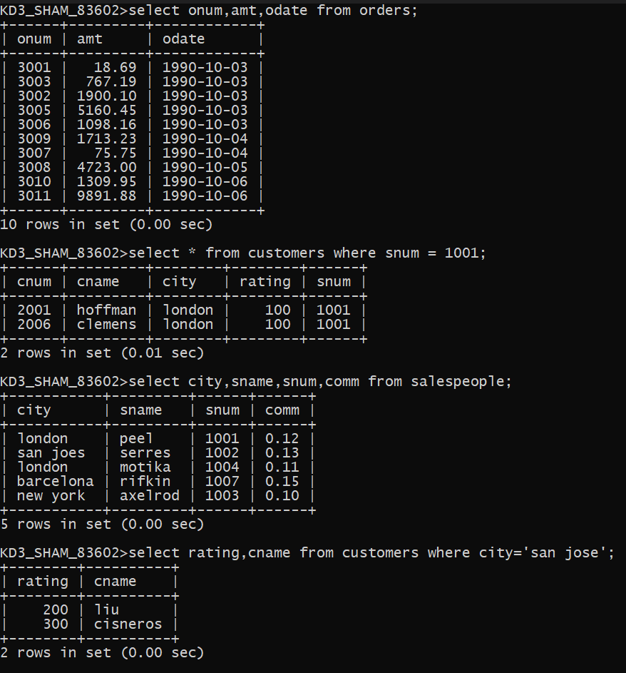
Assignments 5select * from orders where amt > 1000;select sname , city from salespeople where comm > .10 and city = 'london';select *from customers where rating <= 100 and city != 'rome';select *from orders where (amt < 1000 or not (odate = '1990-10-03' and cnum > 2003));select *from orders where not ((odate = '1990-10-03' or snum>1006) and amt >= 1500);select snum , sname , city , comm from salespeople where (comm > .12 or comm < .14);

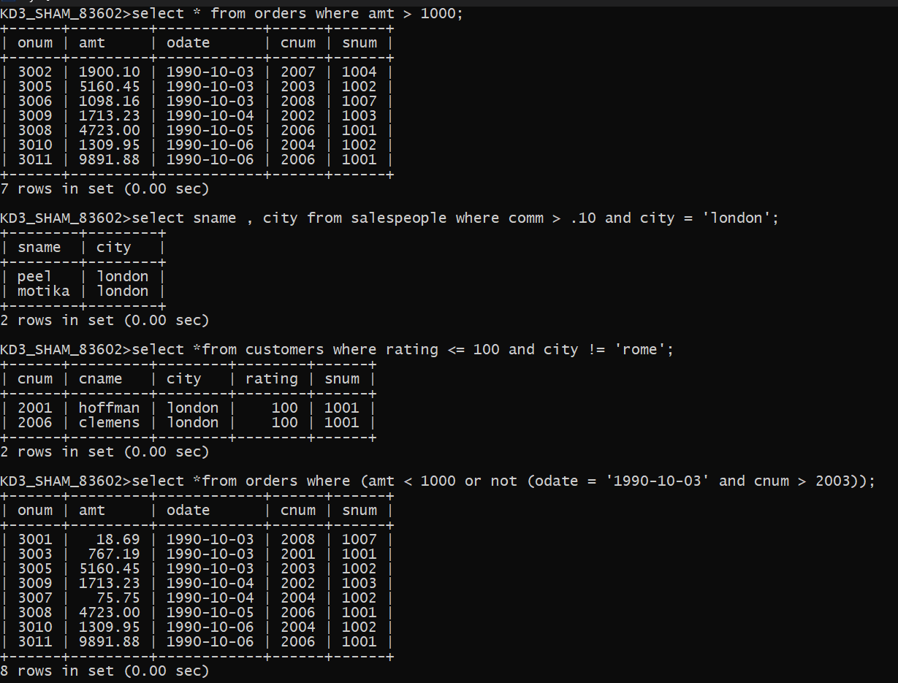
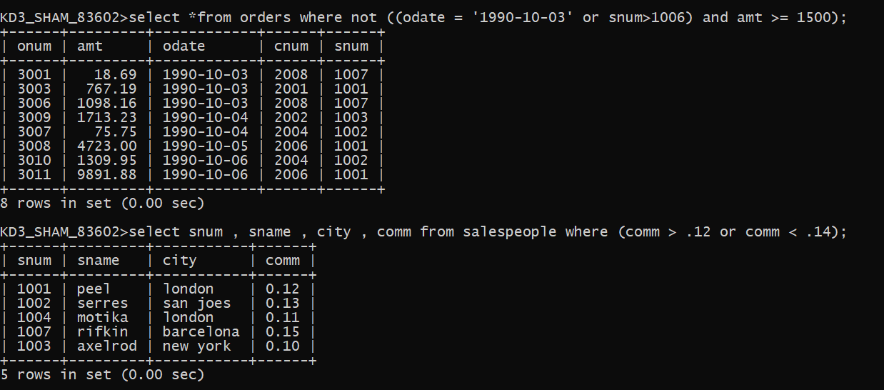 Assignments 6select * from orders where odate between '1990-10-03' and '1990-10-04';select * from orders where odate >= '1990-10-03' and odate <= '1990-10-04';select * from customers where snum in (select snum from salespeople where sname in ('peel' , 'motika'));select cname,sname from salespeople,customers where salespeople.snum =customers.snum having sname='peel' or sname='motika';select * from customers where cname >= 'A' and cname <= 'H';select * from customers where cname like 'C%';select * from orders where amt != '0' OR amt != NULL ;

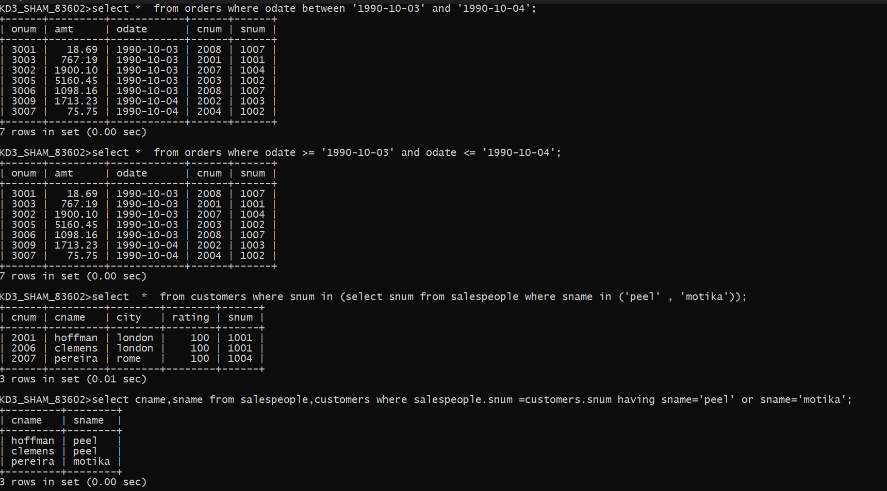
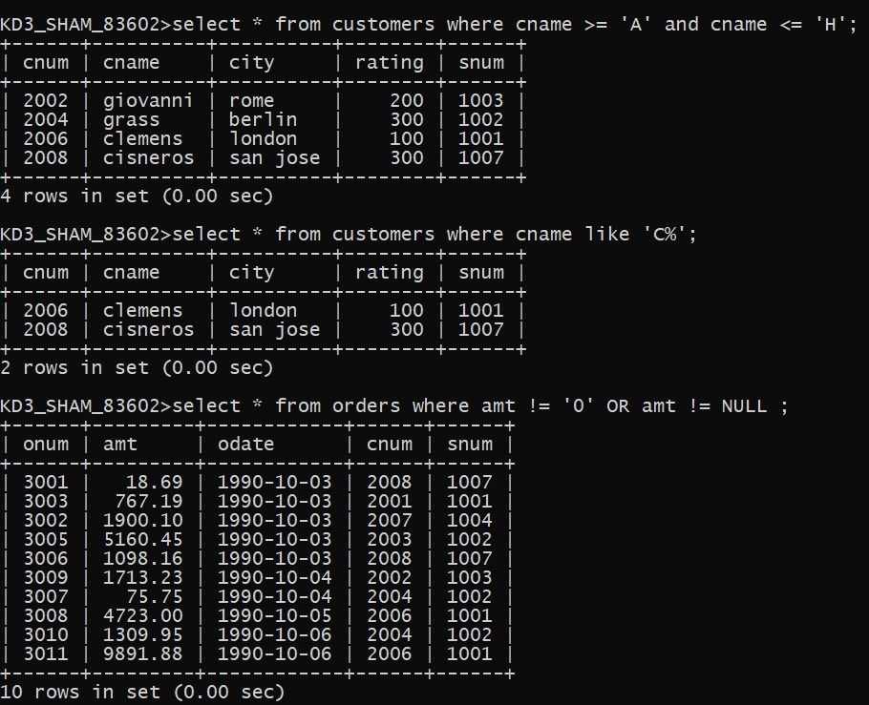
Assignments 7select count(odate) from orders where odate='1990-10-03';select count(city) from customers where city is not null;select min(amt),cname from customers,orders where customers.snum=orders.snum group by cname;select cname from customers where cname like 'g%' limit 1;select max(rating) from customers group by city;select odate, count(distinct snum) from orders group by odate;select odate, count(distinct o.snum) from orders o, salespeople S where o.snum=S.snum group by odate;
